National Injury Prevention Day is November 18
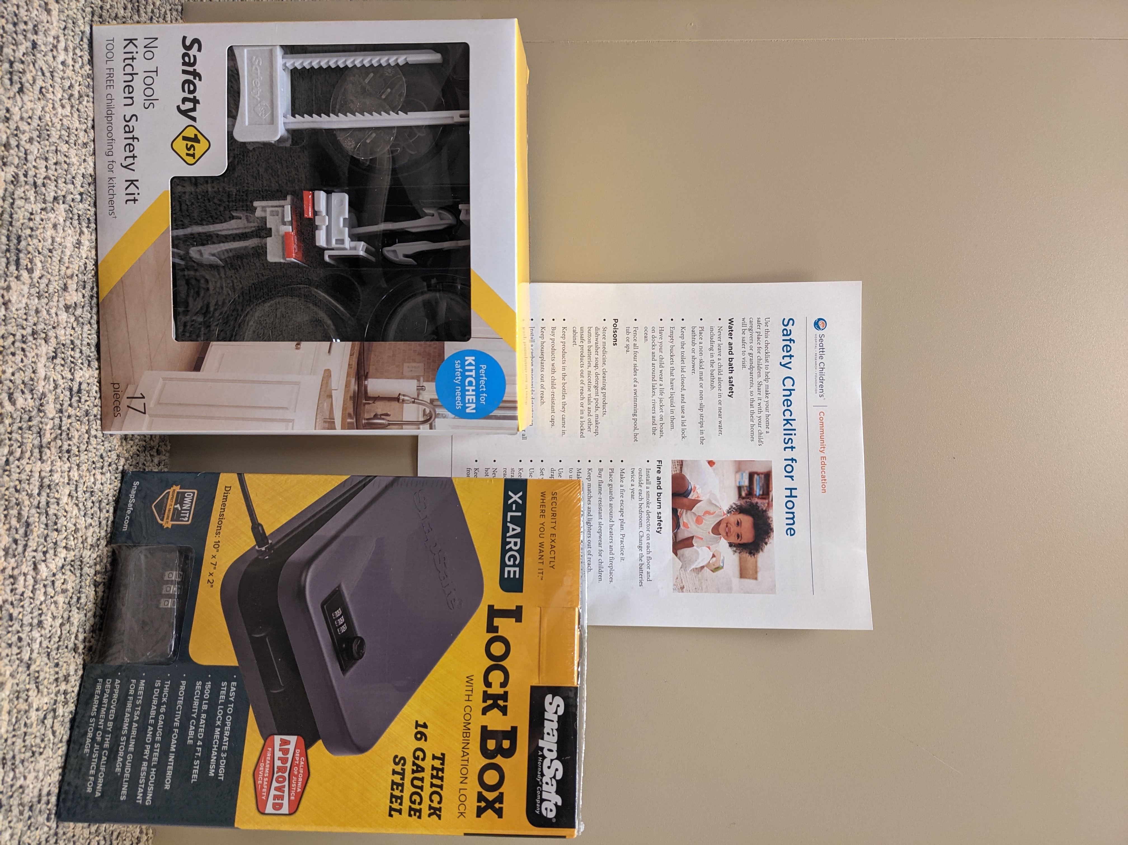
Did you know that injuries, like drowning, firearm related incidents, car crashes, and poisoning are the top cause of hospitalization and death for children and teens? The good news is that there are things that all of us can do to help prevent these injuries.
Firearms and medicine poisoning are two common items involved in injuries, death and suicide. Many homes have both of these things. To help keep kids and teens safe at home and in your community:
- Clean out your medicine cabinet. Get rid of both prescription and over-the-counter medicine (like Tylenol and Ibuprofen) that is expired or no longer needed. Use a medicine disposal kiosk or mail-back service.
- Practice “triple safe” storage by storing firearms:
  - unloaded,
  - locked up
  - separate from ammunition
- Talk about safe firearm storage before sending your child to a playdate, caretaker or relative’s home.
- Use the Safety Checklist to help make your home safer. Share it with those who care for your children.
Enter to win a free safety device!
Share one action you plan to take to help prevent injuries to children and you will be entered to win one device (e.g., firearm lock box, trigger lock, or cable lock, bathroom or kitchen safety kit, medicine mail-back kit, pack and play). Up to a total of 26 devices provided.
For more information:
- Safe Medicine Storage and Disposal to Prevent Misuse
- Firearms in the Home
- Washington Firearm Safe Storage Map for temporary, voluntary storage in crisis situations
- seattlechildrens.org/firearmsafety
- seattlechildrens.org/health-safety
Do you have questions or suggestions to share related to injury prevention? Interested in learning more or finding ways to get involved? Email Isabell.Sakamoto@seattlechildrens.org

